Week In Review July 20 - August 3, 2001
Alex Shvartsman

TEAM GRAND PRIX TAIPEI
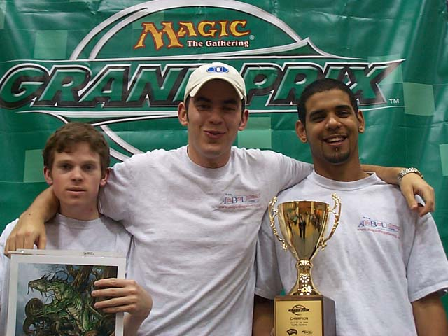
When it comes to Grand Prix in Asia, Japan is the undisputed king, but Taiwan comes a strong second. This was the fourth Taiwanese Grand Prix held on the island over the course of less than three years, and a third held in its capitol city of Taipei. As usual, a number of pro teams traveled from nearby Magic centers such as Hong Kong and Singapore, and a strong Japanese presence was a given. Only two teams traveled from United States - Team Antarctica featuring Dan OMS, Steve OMS, and Jon Finkel, and Team AlphaBetaUnlimited with a couple ringers. Chris Benafel was the only card-carrying ABU member present. Friends Dan Clegg and David Williams joined him, as his European teammates Fuller and Boeken could not make it this time. The new configuration did not stop the team from winning yet another title. In the finals, they defeated a high-profile Japanese Team Anchans, featuring Osamu Fijita, Itaru Ishida, and Rookie of the Year hopeful Katsuhiro Mori.
More of a surprise was Antarctica's final finish - at the opposite end of the Day 2 standings from ABU, in 20th place. Antarctica squeezed into Day 2 at a 4-2 record, losing to the eventual champions ABU in the process, then had a really poor Day 2. "Steve did not cast a spell all day," complained Dan O'Mahoney-Schwartz. A minor setback for Antarctica, but a surprise rare Finkel GP appearance.

CANADIAN NATIONAL CHAMPIONSHIP
Of all the Nationals, this one is especially interesting as the first tournament to utilize Apocalypse in Standard play - except it seems that somebody forgot to notify the Canadians!
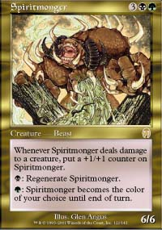
Of the entire Top 8, only Sam Lount used nonland Apocalypse cards in his deck -Lount played a Fires variant with Spiritmonger and Fire/Ice to an eventual third-place finish. Only two other competitors in the Top 8 used Apocalypse pain lands to smooth their mana bases. Neither of the two finalist decks used Apocalypse cards at all. This is hardly because Apocalypse does not feature enough game-altering cards though. "I do not want to hurt my team's chances at Worlds by showing off any new tech at this tournament," admits Sideboard reporter and Top 8 finisher at this tournament Gary Wise. Other players may not have had an opportunity to develop strong Apocalypse-based decks in such a short time.
Even though Apocalypse cards did not make it all the way to the top, the decks succeeding at this tournament will make metagame watchers sit up and take notice. The most successful archetype was Counterrebel, navigated by three of the Top 8 competitors. Other decks included Skies, Opposition/Orb, Fires, and two very rogue decks - Crosis-Go and Digger, both showing up at the Grinders (single elimination qualifiers for Nationals held the day before). Crosis-Go is a black-blue-red control deck similar to Nether Go, using Shivan Reef to smooth out the mana base and splashing red for Urza's Rages both as a control card and a win condition. Digger is even stranger, and hardly looks like a viable deck - yet Ben Raymond managed to both qualify through a Grinder and make Top 8 using this strategy. It is a black-blue reanimator deck with 4 Chromatic Spheres and 4 Recoils as its only non-creature spells. The deck uses Crypt Angel and Gravedigger to bring back its creatures and has a very unorthodox array of cards previously seen mostly in Limited play, such as Urborg Emissary and Cavern Harpy.
Terry Tsang and Elijah Pollock were to meet in the finals. Because of his health condition, Pollock chose to leave the tournament early, conceding the National Champion title to his opponent - his main concern was to qualify for Worlds - a mission that he accomplished successfully.

TEAM GP COLUMBUS
A year ago, Team Grand Prix in midwest gathered somewhere around 60 teams. This time around, it was closer to 200. American players finally seem sold on the idea of playing Magic in teams of three, even if it took a little time.
Many European players have traveled to North America early in order to practice for World Championships with their teammates from across the ocean, as well as compete in this tournament. For example, Kai Budde, Patrick Mello, and Sigurd Eskeland played on the same team, finishing 43rd.
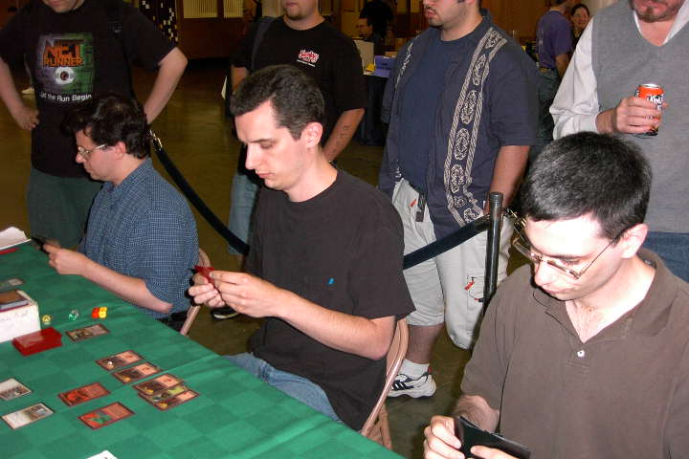
The Ancient Kavus
Top of the standings featured four very strong and very different teams. In fourth place was team Ancient Kavus, featuring Canadians Matt Vienneau and Gary Krakower, and Mike Pustilnik. The three played together at a team PTQ last season, and liked each other enough to team up for the Pro Tour. Vienneau and Pustilnik have both been on the winning streak lately - Vienneau dominating the Grand Prix scene, while Pustilnik led Player of the Year race for most of the season. Two time Canadian National Champion Krakower has been on the down-streak though, and Ancient Kavus fourth place finish should go a long way toward restoring his confidence. It also lets Pustilnik tie with Cornelissen for second place in the POTY race.
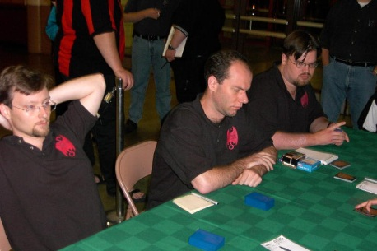
Your Move Games made it look easy
In third place was Team Dynasty - Brian Hacker returns from virtual retirement to test with teammates Ben Rubin and Gab Tsang. The three were not qualified for the team Pro Tour, and made the trip hoping to win an invitation - they succeeded admirably. The second place team featured another almost-retiree - Lan Ho, with teammates Dan Clegg and Ken Ho. Clegg almost won his third team GP in a row - he won in Turin and Taipei with two different teams and came within a match of the three-in-a-row record. Ken Ho (no relation to Lan Ho other than through the team) is now tied for the first place against Lawrence Creech in the Rookie of the Year race, more on that below.
The winning team was Boston's Your Move Games - winners of the first team Pro Tour, Darwin Kastle, Robert Dougherty, and Dave Humpherys proved they are still masters of this format. It is an important win for the YMG crew - Dougherty solidifies his place on the Masters while Kastle gets close to regaining his.

PLAYER AND ROOKIE OF THE YEAR RACE
It all comes down to Worlds. Kai Budde is in a very strong lead, so let us take a look at what players mathematically have a chance of taking him down. Budde is currently at 83 points and, at worst, will gain two more points awarded for attending Worlds. Winning the championship is worth 32 points. Thus, only players with 53 or more points still have a shot. Here they are:
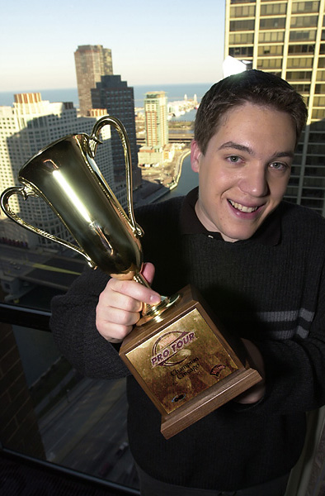
Kai's looking for another trophy
Kai Budde Germany 83
Michael Pustilnik USA 69
Kamiel Cornelissen Netherlands 69
Ryan Fuller Netherlands 62
Chris Benafel USA 59
Zvi Mowshowitz USA 56
Daniel Clegg USA 56
Scott Johns USA 55
Pustilnik or Cornelissen would have to finish at least in the Top 4 in order to have a chance at catching Budde - and higher if Budde does better than simply show up.
While no one else is going to get the coveted title, another important milestone is to place in the Top 5. These players will be invited to compete at the Magic Invitational in South Africa this winter.
A much closer race is in the Rookie of the Year category. There, Ken Ho and Lawrence Creech are tied for first at twenty five points, with Katsuhiro Mori only two points behind them. The following players are above ten points:
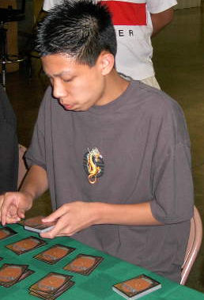
Ken Ho could take the Rookie of the Year title away from longtime leader Creech
Ken Ho USA 25
Lawrence Creech USA 25
Katsuhiro Mori Japan 23
Markus Joebstl Austria 19
Johan Sadeghpour Sweden 18
Danny Mandel USA 18
Dustin Stern USA 15
Brian Hegstad USA 14
Tomohiro Maruyama Japan 14
Jan Doise Belgium 12
Yuri Kolomeyko Ukraine 12
The Rookie title is anyone's game - a player who qualified through their Nationals might end up winning Worlds and earning the title. However, a more likely scenario is a battle between the top three - all of them have been doing steadily well in the tournament scene this year and watching them battle it out will add excitement to the tournament.

COMING UP: WORLD CHAMPIONSHIPS

A five-day long spectacle will see over 200 players compete in a variety of tournament formats. After player registration and traditional player party on Tuesday, the event will begin with Standard play on Wednesday. Except for the Canadian Nationals, this will be the first major event to utilize Apocalypse and will likely set the Standard metagame for months to come. The second day will feature Invasion Block Rochester draft - also an interesting format that has not been played very much at high levels. Invasion Block is an extremely difficult format to play well in Limited, and so practice and talent should be well rewarded. The third day will be Extended - the first major Extended tournament since the Pro Tour-Chicago a year ago. With so many new sets added to the format, and the bannings of cards like Demonic Consultation, we might see some new archetypes spring up in this format.
About a third of the field will take a break on Saturday, while players on National Teams battle it out for the team prize. Each of the three players on a National team, earns his team points during the three days of individual play - but it is the team play day that really decides the victor. The format will be Team Sealed. With a lot of cash added to the team prize structure this year, and the Pro points involved, this day of competition has become much more important.
The tournament will culminate in the final matches on Sunday, where top players will revisit their Standard decks. At the end of the day, the new World Champion, new Player of the Year and new Rookie of the Year will be crowned.
As I will be competing at Worlds, the next installment of this column will be published during the following week. Wish me luck!

MAGIC TRIVIA
Last week's Question:
Who was the first Magic pro to reach (highest) level 60 in EverQuest on-line role playing game?
Lacking a precise date, it is a tie between US National Champion Dennis Bentley and PT champion Olle Rade from Sweden. EverQuest has taken over the lives of many a Magic player. Bentley quit Magic partly to pursue EverQuest, but many others, including Rade and current rookie of the year Brian Davis, manage to find the time for both.
New Question:
What promotional card was given out to participants and spectators at the 1999 World Championship in Yokohama, Japan?
Please do not e-mail me your answers. The correct answer will be posted in next week's column.

PLAY OF THE WEEK
Courtesy of Yaroslav Berezovsky, Russia:
"This happened during a small local tournament. I was playing Go-Mar vs. an aggressive three-color deck, and I was beating my opponent down with a Spectral Lynx. I was dangerously low on counters and knew he had a Mystic Snake in hand, which he had Repulsed some time ago. Eventually my opponent played a Questing Phelddagrif, which could let him win the game in two turns. I cast Gainsay on the Phelddagrif, and my opponent played Mystic Snake. I only have one Disrupt remaining in hand along with some lands, and Disrupt my Gainsay in response to the Snake. Fortunately, he could not counter Disrupt. I refused to pay one mana for it thus, countering my Gainsay, and drew another land. The Snake came into play afterward, and found only one spell on the stack, namely Questing Phelddagrif... and no, it doesn't say "you may counter target spell." I was then able to win the game, since I had a Meddling Mage to block the Snake. I don't actually think it's good enough to qualify as a play of the week, but thought you might like it anyway..."
On the contrary, this is one of the better plays I've had the privilege to post in this column, since it relied on some excellent resource management and original play, rather than top-decking the right card.

BAD PLAY OF THE WEEK
Courtesy of Pedro Ceriotti, Uruguay:
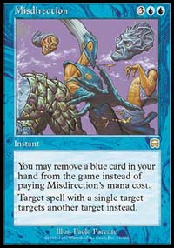
"It happened during this year's Uruguay National Championship. It's the final game of the final match and Alexander Westerley was playing his "Nether-Go" deck against Rodrigo Asuaga's "Sloogh." Both players were down to only two life points, but Alexander was clearly in control of the game. Alexander's Nether Spirit was hitting for those last couple of life points to a win next turn. Rodrigo feared all along that Alexander might have an Undermine or Misdirection, so he couldn't take the risk to cast some spell, but now everything seemed lost anyway, so he decided to try. He played a couple of creatures that get countered by Alexander's plain old Counterspells, which left both players with only one card in their hands each.
Rodrigo played his Urza's Rage targeting Alexander. Alexander looked at the Rage, looked at the only card remainin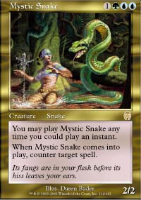g in his hand and counted his lands, he had five islands untapped. Then, Alexander scooped. Rodrigo reached over to shake Alexander's hand and Alexander revealed the card in his hand, a Misdirection, and said: "I was going to win next turn. You were lucky I only had five mana remaining and couldn't play this".
As always, please send good/bad plays, cool trivia questions, and other news to ashv@concentric.net

